

Mitglied der Helmholtz-Gemeinschaft

Quick Start Guide

Installation 1

Installing Macros 1

Installing ROI Splitting Tool 2

Image Analysis 3

Pre-processing 3

Processing 4

Post-processing 8

Executing Tracking and Validating Results 10

Tips and Tricks 11

Exemplary data sets 12

Troubleshooting 12

Update Sites 12

# Installation

Mitglied der Helmholtz-Gemeinschaft

* Download the last stable version of Fiji from [Jenkins](http://jenkins.imagej.net/job/Stable-Fiji/lastSuccessfulBuild/artifact/fiji-win64.zip)
* Extract the archive (and move *Fiji.app* to your User folder – **do not** install it to *Program Files*)
* Launch *Fiji.app/fiji-win64.exe*
* If this is your first start, Fiji will ask you to install updates which you should allow
* After a restart, add repository of the plugin to the Fiji Updater as follows:

|  |
| --- |
|  |
| ImageJ Updater window |

* Go to *Help > Update Fiji* and wait till the Fiji Updater window opens
* Press the *Manage update sites* buttons

|  |
| --- |
|  |
| Update Site Manager |

* Add the URL *https://ibtmodsimhub.ibt.kfa-juelich.de/imagej/jungle-dev/* to the update sites via the *Add* button (the name does not really matter, as long as you will be able to identify the update site later..)
* Press *Close*
* The Fiji Update will now show available updates / installable plugins
* Install all files from the newly added update site
* Restart Fiji

## Installing Macros

1. Go to *Plugins > Macros > Install*
2. Select StartupMacros.ijm in the Fiji.app/macros folder (which should be the default case…)

## Installing ROI Splitting Tool

1. Go to Plugins > MASTER PLUGIN
2. Deselect Preprocessing and Segmentation
3. Start the plugin

Mitglied der Helmholtz-Gemeinschaft

# Image Analysis

Mitglied der Helmholtz-Gemeinschaft

## Pre-processing

* Crop single cultivation chambers from the original ND2 file
* Launch Fiji
* Import via *File > Open*
  + You can also drag a file onto Fiji’s main window
  + If your image seems to be empty / completely dark, take a look at section*What if I can’t see anything in the image?**.*

### What if I can’t see anything in the image?

If can’t see anything (or you only see a black image) it is very likely that some brightness or contrast settings have been determined incorrectly. Usually this is not a problem for phasecontrast but for the fluorescence channels.

You can correct this by setting the values manually. To do so open *Image > Adjust > Brightness/Contrast…*. You can see the distribution of values at the top of the window. If you image is all black it is very likely, that the right value below the distribution is very high (something like 65000). To change that value automagically just move the handlebar for the maximum value slightly to the left and back to the rightmost position. This will set both the minimum and the maximum value according to the currently shown image.

If you know your background fluorescence signal, you can move the minimum to that value (or a little higher). This will effectively hide pixels with signals lower than the minimum.

|  |  |  |
| --- | --- | --- |
|  |  |  |

Table 1. A) The location of the Brightness/Contrast tool in the menu structure. B) The distribution and values before any correction. C) After correcting the minimum and maximum values, respectively.

## Processing

Mitglied der Helmholtz-Gemeinschaft

* Launch single-cell analysis plugin *Plugins >MASTER PLUGIN*
* Decide which steps to execute in the *Pipeline Composition* tab
* Select a profile in the *Segmentation* tab, c.f. Profiles explained
* You can try to keep the default options. If you are not satisfied with the results take a look at the section that describes the procedure for determining optimal parameter values How to determine values for filters

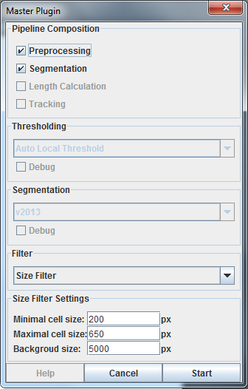

* The tool is trying to automatically detect the cultivation chamber, if it couldn’t be detected you have to select it manually when you are asked to do so (see screenshot). However, you can also force a manual selection by creating a rectangular region of interest as described below before you start the *Master Plugin*.

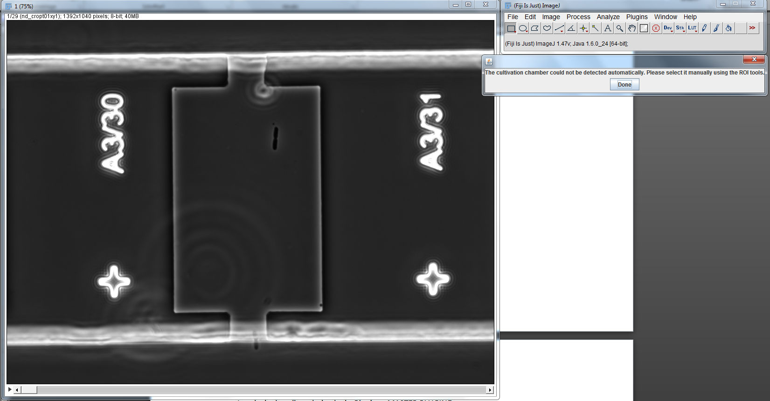

* Use the rectangular selection tool.

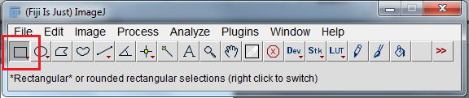

Mitglied der Helmholtz-Gemeinschaft

* To select the cultivation chamber as such:

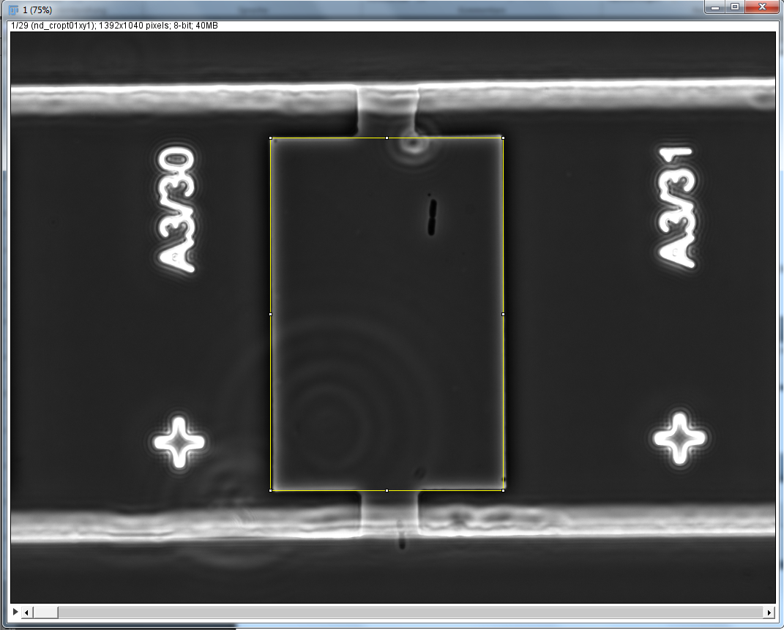

* Afterwards click done and the plugin is going to detect and analysis the single cells in the frames

### Filters explained

Filters are used to determine if a detected cell is valid or if it has to be processed to generate a valid cell. A simple example is the size filter. It discards cells completely according to two cut off values, marks them for further processing if an object is unlikely to be a single cell, or detects the object as a single cell (in which case no further processing is done), respectively.

Further processing comprises the attempt to split up the objects meaningfully. In short, it searches for the two closest points on the objects contour and connects those points with the split line.

### How to determine values for filters

Several filters are already implemented for which there are different procedures to determine optimal parameters if possible at all:

#### Size Filter

Mitglied der Helmholtz-Gemeinschaft

The size filter offers three parameters:

*Minimal Cell Size*

Objects that are smaller than this threshold are discarded.

*Maximal Cell Size*

Objects that are smaller than this value will be regarded as single cells, thus, no further splitting mechanisms are applied.

*Background Size*

Cells that are smaller than this threshold but larger than the maximal cell size value are further processed. An algorithm is applied that tries to split up the cells since their size seems to be non-standard. Object larger than this value are discarded.

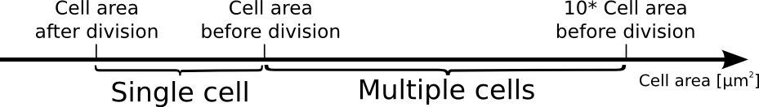

You can determine optimal values for you data by measuring

* Cell area after a division,
* Cell area before a division,
* Summing up a normal cell area times ten.

To do so:

1. Window of *Analyze > Set Measurements*
2. Tick the boxes as shown in the screenshot
3. Select a cell
4. Click *Analyze > Measure* or hit Ctrl + M
5. A results window will pop up and show the detected area

|  |  |  |
| --- | --- | --- |
|  |  |  |

Table 2. A) Window of *Analyze > Set Measurements*.. B) Select a cell. C) Results table generated by *Analyze > Measure*

#### Convex Hull Filter

Mitglied der Helmholtz-Gemeinschaft

Actually this filter should be called solidity filter. The idea is, however, the same: compute the convex hull of an object and compute the ratio of its area to the convex hull as shown in Figure X.

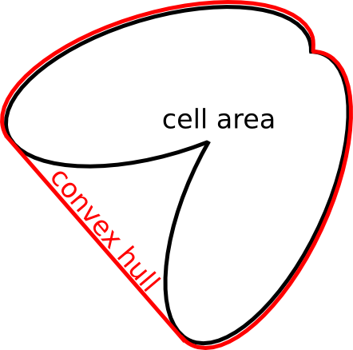

Table 3. xxx

Therefore, you should set the deviation value to about *0.20*. The lower the value, the more perfectly shaped a single cell has to be in order to not be split.

#### Size and Convex Hull Filter combined

The idea is to filter small and large objects according to the minimal cell and maximal cell size, respectively. Consequently, the solidity filter is applied to the remaining objects.

#### No Filter

(not implemented yet..)

#### Shape Filter

(not implemented yet..)

### Profiles explained

Profiles are a way to fine-tune the segmentation procedure. This includes the number and parameters of morphological operations as well as thresholds. Parameters for morphological operations have to be defined according to image data (especially resolution).

Therefore, *Default, Balaban*, and *DFG* should be used with the new camera (high-resolution images). *Sophie* and *Raphael* can be used with data acquired with the old camera (low resolution images).

## Post-processing

Mitglied der Helmholtz-Gemeinschaft

After a couple of seconds the tool has detected various objects, not always cells, in each of the given frames. The detected objects are highlighted by yellowish curves. Furthermore, the number of cells and overall size of each frame is shown in the *General Results* windows.

|  |  |  |
| --- | --- | --- |
|  |  |  |
| Imported images series |  | General Results windows |

Go through each of the frames and check if:

* only cells are detected and no other objects
* that the cell was recognized entirely
* cells were separated correctly

To correct the results, you have the following options.

### Add a cell

1. Activate one of the Selection tools. I suggest using the Ellipse tool that can be activated by right clicking the oval:

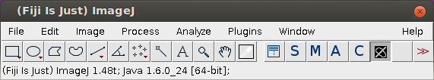

**Selection Tools**

1. Go to the image and create a cell (=region of interest)

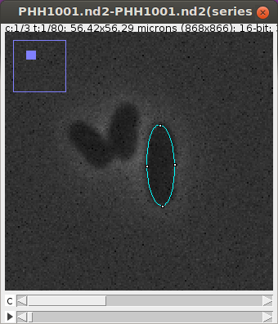

Mitglied der Helmholtz-Gemeinschaft

1. Click the A in the toolbar (or hit a on the keyboard; if this doesn’t work go to Installing Macros)

### Remove a cell

1. Activate the ROI Splitting tool (if it is not in the toolbar got to Installing ROI Splitting Tool)



1. Select a cell by clicking it
2. Backspace to delete it

### Split a cell

1. Activate the ROI Splitting tool



1. Select the cell you want to split
2. Somewhere outside of the selected cell left click and hold down the mouse button. A red dashed line will show you the splitting line along which the cell will be split after you release the mouse button.

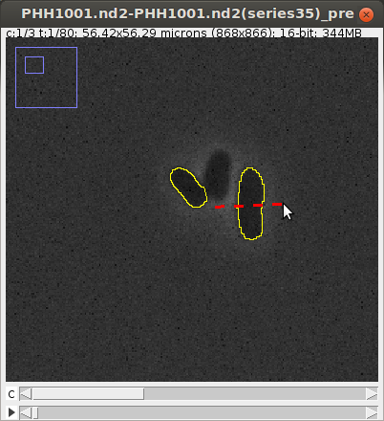 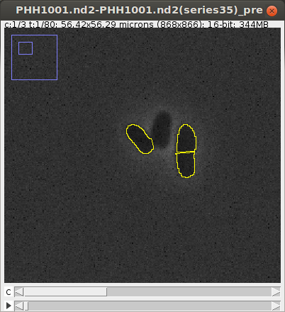

### Merge two cells

1. Activate the ROI Splitting tool



Mitglied der Helmholtz-Gemeinschaft

1. Activate the image window (by clicking its title bar)
2. Hold down the Shift key and select to cells

### Save the results

Once you are satisfied save the resulting file via *File > Save as > Tiff…*

### Measurement data

Measure ROIs and export results

* Click on  to create a new *General Results* table.

Save data using *File->Save as …*

## Executing Tracking and Validating Results

1. Open *Plugin > Tracking > TrackMate* (the windows that opens will guide you through the process)
2. 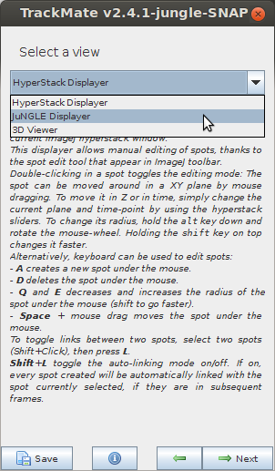Set the *Time interval* according to the experiment, e.g. 480 sec for an experiment with 8 minutes imaging interval
3. Select the *Overlay Detector* and click *Next*
4. Click *Next*
5. Wait for the results to be processed and click *Next*
6. Click *Next*
7. Select the *JuNGLE Displayer* and continue (see right)
8. Click *Next*
9. Select *LAP Tracker* and click *Next*
10. Scroll down and check *Allow track segment splitting*, decrease the *Max distance* to 7.5μm and start tracking by clicking *Next*
11. Click Next
12. In the display options window select the *Track display mode* to be *Show Local Tracks, forward* and set the *Frame depth* to 5.
13. Start the lineage view by clicking *Track scheme*
14. If you find a segmentation problem
    1. Select the JuNGLE tool  
       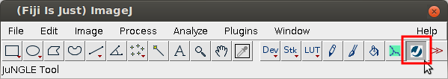
    2. Correct the segmentation (see e.g. Split Cells)
    3. Remove unnecessary spots
    4. Add new spots (double click to the inside of the ROI and double click the appearing spot again)
15. If you find a misassignment in the image sequence (by going through it frame by frame):
    1. Find the correct assignment and select both pink dots (in the image windows) by holding Shift and clicking
    2. Now open Track Scheme and right click in an empty space
    3. Select *Link 2 Spots*
    4. Now that the correct assignment is set, remove the connection to the old parent by selecting the edge and hitting the Del key

Once you are finished, save the results (click *Save*, which will open the file selection dialog) in a file that is named like image but with xml file extension (should be the default case…)

# Batch processing of data

Mitglied der Helmholtz-Gemeinschaft

Currently, there is no user interface available to start a batch processing job. However, a macro *ProcessOpenImages.ijm* can be used to sequentially process all open images with the parameters provided in the macro.

Line 43: *run("MASTER PLUGIN", "segmentation profile=balaban filter=sizeandconvexhull minimalSize=0.7 backgroundSize=41.3 deviation=0.20");*

This line will execute the plugin with only the segmentation enabled (to have it otherwise, just prepend the second string with preprocessing). It will use the profile named Balaban and apply the Size and Convex Hull filter with the provided parameters.

**Just like in the usual workflow (starting Master Plugin) you have to set parameters before you execute the macro the first time.**

When you execute this macro, all open images will be marked for processing. Therefore, do not close images after you have started this macro. The resulting files will be saved to the same folder as the input image. If, for some reason, this is not possible, it will be saved to temp.

If you want to use this feature, get in touch with me for further information!

# Tips and Tricks

* Check the last frames of a sequence for the filling level. If the chamber is too full (to your opinion) duplicate the image (which can be used for cropping it in time dimension):
  + *Image > Duplicate* (or hit Ctrl+Shift+D)
  + Select the previously determined last frame of the final sequence and put it in the *Frames (t)* field as last frame
* Sometimes it is easier to work with the built in Selection tools
  + In order to be able to work with them, enable the labels of the detected cells: open *Images > Overlay > Labels…* and select the Color (white works well) which will also check the Show Labels box automatically (if not, do it manually). You c
  + You can also use Selection tools without the labels by clicking a cell a little longer than a standard click (about 0.5sec)
* In a stack with multiple channels you can go to the next time frame via CTRL + 🡪
* Try restarting Fiji

# Exemplary data sets

Mitglied der Helmholtz-Gemeinschaft

You can find exemplary data sets containing pre-processed and segmented image series of *Corynebacterium glutamicum* and *Escherichia coli* here:

# Troubleshooting

Please report any issues regarding the plugin here: <http://ibtmodsimhub/trac/ij-plugin/>

You can use you Windows user and password to log in and issue a new ticket. Please describe your problem as detailed as possible while keeping the title short and concise.

# Update Sites

<http://ibtmodsimhub/imagej/jungle-dev> (current development version)

<http://ibtmodsimhub/imagej/jungle> (stable version)

# Version History of the Documentation

Mitglied der Helmholtz-Gemeinschaft

### Version 1.6 (2015-04-28)

* Updated URL of update-site

### Version 1.5 (2014-12-22)

* Added documentation for new JuNGLE viewer
* Moved version history to the end of the document

### Version 1.4 (2014-06-18)

* Integrated descriptions of profiles in general and in detail
* Added documentation for “batch processing”
* Fixed design (now corporate design)

### Version 1.3 (2014-04-15)

* Integrated second tutorial / guide to analysing DFG data since it describes the new overlay-based tools and workflow
* Updated some screenshots that were outdated

### Version 1.2 (2014-02-19)

* Updated installation chapter (now includes the information to not install to Program Files)

### Version 1.1 (2014-02-03)

* Updated *Import Sequence* screenshot: removed explicit conversion to 8-bit from pre-processing section since version 0.3.0 of the plugin is also able to process 16-bit images
* Included possibility to trigger manual chamber selection by having a ROI active before starting the Master Plugin
* Incorporated delete macro in post-processing section
* Fixed some typos

### Version 1.0 (2013-09-13)

Initial version of this document written by Christopher Probst